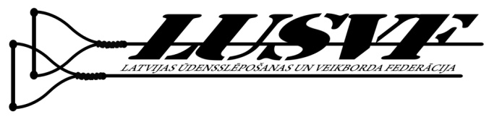


Form – Intention to participate in 2013 Wakeboard Boat Judging

Your Name: _____________________________________________

Federation: _____________________________________________

Arrival date and time: _____________________________________________

Departure date and time: _____________________________________________

Additional requests: _____________________________________________

Saturday night diner: I will Participate I will NOT Participate

